LÊ THANH TÙNG
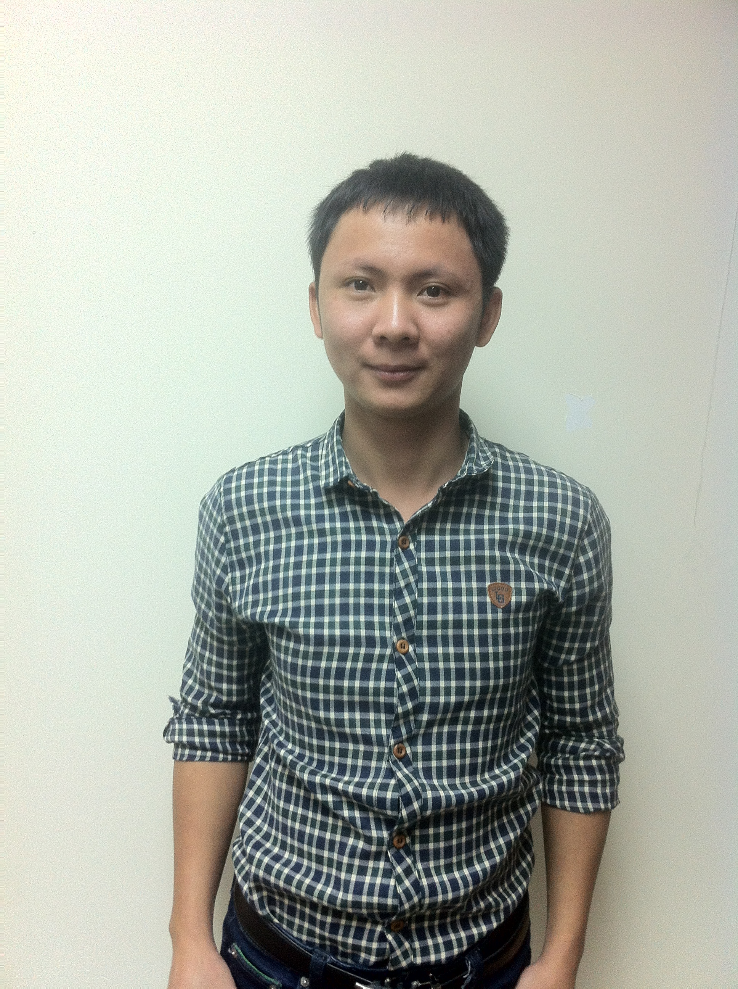

PERSONAL DETAILS

- Name LÊ THANH TÙNG
- Nationality Vietnamese
- Date of Birth January, 2th 1991
- Sex Male
- Marital status Single
- Phone No. (84) 1667129176
- Email thanhtung0201@gmail.com

EDUCATIONAL BACKGROUND

- 2009 – 2014 : Hanoi University of Science and Technology – Vietnam
Major : Information System
Degree classification : Good

PROFESSIONAL SUMMARY

- Highly skilled IT professional with two years professional experience including application development, implementation, deployment, internal and customer support.
- Using basic tools and software of Windows
- Strong points : Responsibility, adaptability, friendly, teamwork, creative ideas
- English Skills :Writing and speaking , Good Listening and Reading
Certificate : TOEIC IIG 735

SOFTWARE

- Databases : Oracle , MySQL (Familiar use SQL Developer or SQL Navigator tool)
- Programming Languages: Java , C, Javascript, CSS, HTML, XML,Ruby on Rails (Experience Java over 2 years working, other languages : at least 1 year)
. Using some frameworks such as Struts , Spring MVC,Hibernate , Jquery, Angular JS,Bootstrap and other Java librarys. Writing clean code, follow coding convention, know design partern Java, know and apply security for Java web .Familiarity developing with component-based MVC , Java Unitest …
- Programming Tools: Netbean, Eclipse, Sublime, Notepad++...
- App server / Middleware: Tomcat (Experience in deploy App Tomcat server)
- Configuration Management tools: SVN, Git
- Knowledge of object oriented analysis and design (UML), relational database management (My SQL Server, Oracle)

OPERATING SYSTEMS

- Windows, Linux basic

PROFESSIONAL EXPERIENCE

April 2016 – Until Now

Role : Developer

Savis VietNam Corporation

Project : ADB-BYT

Project Description:

This symtem helped clinicial speciallists signed up the certificate of practiced medicine, and department of clinics were diagnosing, treating which signed up working license in around their country local.

Website http://hethongquocgia.hny1.vn/

Team size : Over 15 people ( including developers, testers, BAs, Project Manager)

Project size : Big

Responsibilities:
- Fix bug and perform some new functions
- Convert ,standard,migrate data format from old system to this system

Technologies Language:
- J2EE (Wak framework) , Jetty server, PostgreSQL

October 2014 – March 2016

Role : Developer

Viettel Software Center –VTSOFT

Main Project: GHR (Global Human Resource)
Project Description:
System is created to help human resources staffs store and manage employee info flexibly, simply and conveniently.Helping manage human resources effectively

Domain: HR Management and payroll System for Viettel Saff working in Foreign Countries

Team size: 3 main peoples and other members
Project size: Big
- Time : From Before 2015 until now
- Number of Users : About 1000 users include management human at deparment, devision, group in all the countries foreign in which Viettel invest

Responsibilities:
- Analyze the requirement
- Design database and Prototype
- Coding and unit testing

Technologies Used:
- J2EE , Struts and Hibernate Framework and other java libs
- Client : JQuery and Bootstrap framework

Configuration :
- Server : Linux or Windows 2003 Server
- Jdk 1.6 or later version
- Tom cat 7.0 or later version
- Database : Oracle 10g , about 200 tables
- System includes 3 apps : GHR , VPS, CAS and 2 databases vps, ghr
- VPS : Manage user, create role, permission, menu for user.Just using for some peoples such admin or other supper managements.When user login into GHR , it will call webservice is provided by VPS in order to get menu , role, permission for user
- CAS : Using for authentication user . Both VPS and GHR are connected to CAS to authenticate before login into system
- GHR : Main app ( manage about 17000 employee to execute business )
- Deploy on 6 server using load balancing
- Additionally, Provide some services for other systems and using some service are provided by other systems

Other projects
Role : Developer
- VPM , VHR (Management Human and Payroll for Viettel Employee working in VietNam)
- ESS : Employee Self Service ( Font-end of VHR, VPM, GHR) .Helping employee can view info personality ( info timekeeping,workprocess,payroll, education….).

2014/06 – 2014/09
DKT : POS ( Point Of Sale)
- To learn about business and begin develop system in Android.
- Role : Developer
- Size : 9 member ( Include 2 back-ends, 2 ios, 2 android and 2 web font-end developers, 1 Project manager)

2014/01 – 2014/04
FPT Information System – FIS Bank
- Role : Intership
- Description : Learn about oracle sql, fix some mirrors bug relate to Project, writing some simple sql
- Time : Partime
In University:
- Some small projects like management library , game soduku, project based knowledge system…..

